Single Correct Choice
Question English | Which is not deflected by magnetic field –  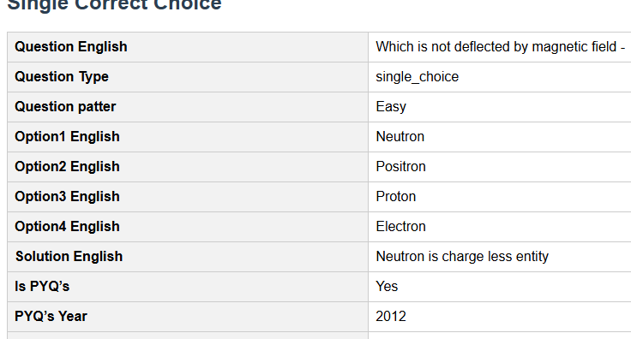
Question_hindi
Question image
Question Type | single_choice
Question patter | Easy
Option1 English | Neutron
Option1 hindi
Option2 English | Positron
Option 2 Hindi
Option3 English | Proton
Option 3 Hindi
Option4 English | Electron
Option4 Hindi
Solution English | Neutron is charge less entity
Solution Hindi
Is PYQ’s | Yes
PYQ’s Year | 2012
Correct Answer | A

Multiple Correct Choice
Question English | Number of ∴[∴αλπηα ∴]-particles scattered by an angle ∴[∴τηετα ∴] in Rutherford's experiment are -
Question_hindi
Question image
Question Type | multiple_choice
Question patter | Easy
Option1 English | Directly proportional to \[K.{E^2}\]
Option1 hindi
Option2 English | Directly proportional to \[{z^4}\]
Option 2 Hindi
Option3 English | Inversely proportional to \[{e^4}\]
Option 3 Hindi
Option4 English | Inversely proportional to \[K.{E^2}\]
Option4 Hindi
Solution English
Solution Hindi | \[N\left( \theta \right) \propto \frac{1}{{K.{E^2}}}\]Inversely proportional to \[K.{E^2}\]
Is PYQ’s | No
PYQ’s Year
Correct Answer | A, B, C

Integer Choice
Question English | The frequency of one of the lines in Paschen series of a hydrogen atom  is \[2.34{\text{ }} \times {\text{ }}{10^{14}}Hz\]. The higher orbit,  \[{n_2}\], which produces this transitions is -
Question_hindi
Question image
Question Type | integer
Question patter | Medium
Solution English
Solution Hindi
Is PYQ’s | Yes
PYQ’s Year | 2018
Correct Answer | 10

Numerical Choice
Question English | In two H atoms X and Y the electrons move around the nucleus in  circular orbits of radius r and 4r respectively. The ratio of the times taken  by them to complete one revolution is -
Question_hindi
Question image
Question Type | Numerical
Question patter | Easy
Solution English
Solution Hindi
Is PYQ’s | Yes
PYQ’s Year
Correct Answer | \[\frac{1}{8}\]

Ture & False
Question English | The charge to mass ratio of the particles in cathode rays is greater than  that of the particles in anode rays.
Question_hindi
Question image
Question Type | boolean
Question patter | Easy
Solution English | e/m ratio of \[{e^-}\]> e/m ratio of P
Solution Hindi
Is PYQ’s | Yes
PYQ’s Year
Correct Answer | true

Assertion and Reason
Question English | Choose any one of the following four responses.
Question_hindi
Question image
Question Type | single_choice
Question patter | Easy
Assertion English | The charge to mass ratio of the particles in anode rays depends on  nature of the gas taken in the discharge tube.
Assertion Hindi
Reason English | The particles in anode rays carry positive charge.
Reason Hindi
Option1 English | If both Assertion and Reason are true and the Reason is correct  explanation of the Assertion.
Option1 hindi
Option2 English | If both Assertion and Reason are true but the Reason is not a correct explanation of the Assertion.
Option 2 Hindi
Option3 English | If Assertion is true but the Reason is false.
Option 3 Hindi
Option4 English | If Assertion is false but Reason is true.
Option4 Hindi
Solution English | anode rays deflect to –ve terminals.
Solution Hindi
Is PYQ’s | Yes
PYQ’s Year
Correct Answer | B

